QUESTIONS:

1. **Update the daily rate for a Mercedes car to 68**

update Vehicle set dailyRate = 68.00 where make = 'Mercedes';

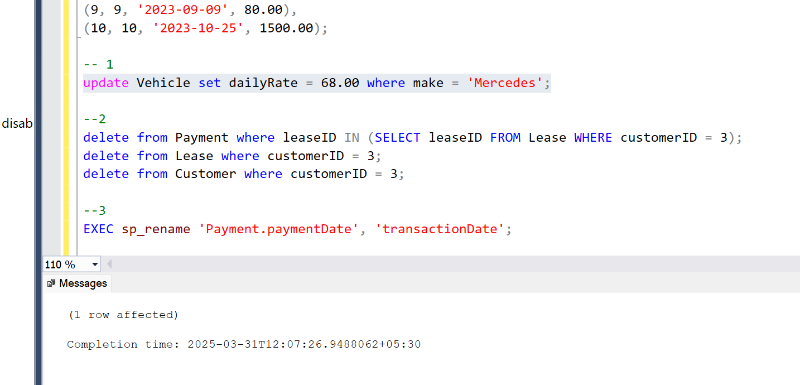

1. **Delete a specific customer and all associated leases and payments.**

delete from Payment where leaseID IN (SELECT leaseID FROM Lease WHERE customerID = 3);

delete from Lease where customerID = 3;

delete from Customer where customerID = 3;

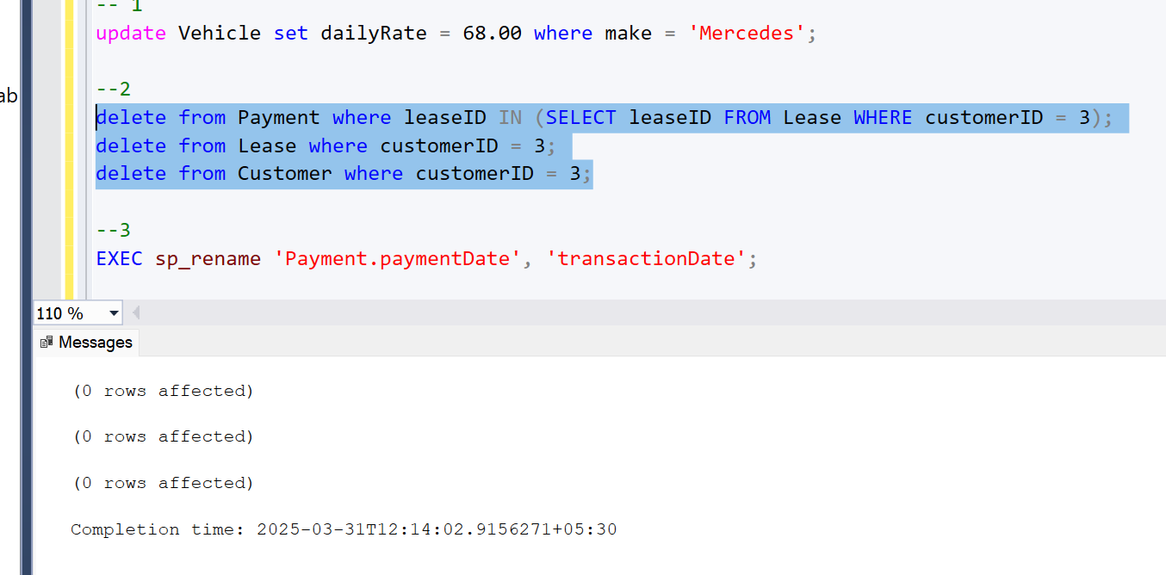

1. **Rename the "paymentDate" column in the Payment table to "transactionDate".**

EXEC sp_rename 'Payment.paymentDate', 'transactionDate', 'COLUMN';

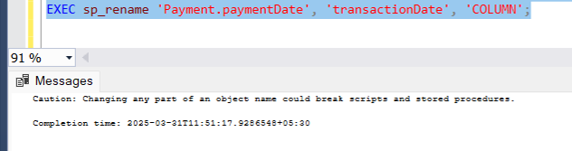

1. **Find a specific customer by email**

select * from Customer where email = 'johndoe@example.com';

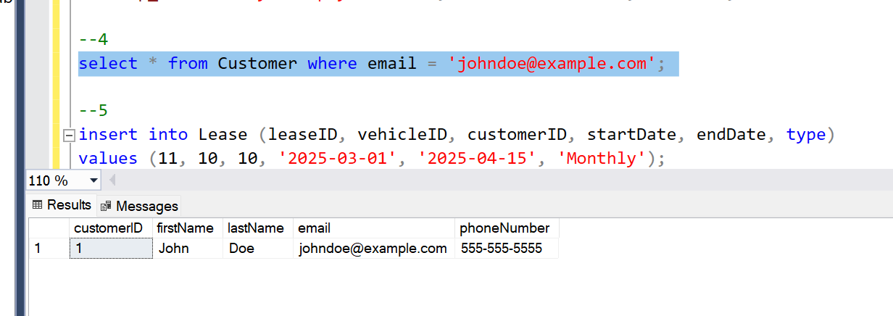

1. **Get active leases for a specific customer.**

**For this I inserted a new data and performed operation**

insert into Lease (leaseID, vehicleID, customerID, startDate, endDate, type)

values (11, 10, 10, '2025-03-01', '2025-04-15', 'Monthly');

select * from Lease where customerID = 10 AND endDate >= '2025-03-30';

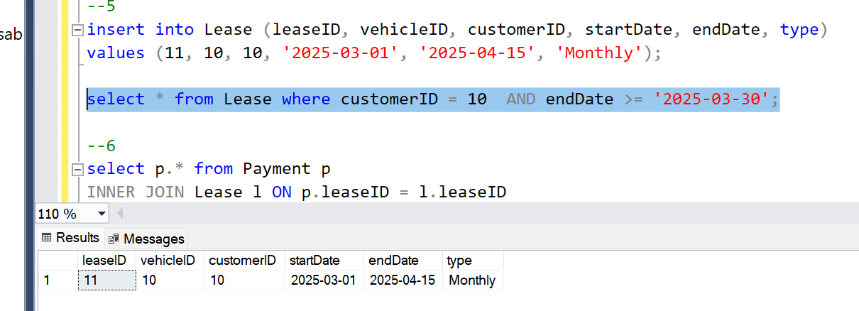

1. **Find all payments made by a customer with a specific phone number.**

select p.* from Payment p

INNER JOIN Lease l ON p.leaseID = l.leaseID

INNER JOIN Customer c ON l.customerID = c.customerID

where c.phoneNumber = '555-555-5555';

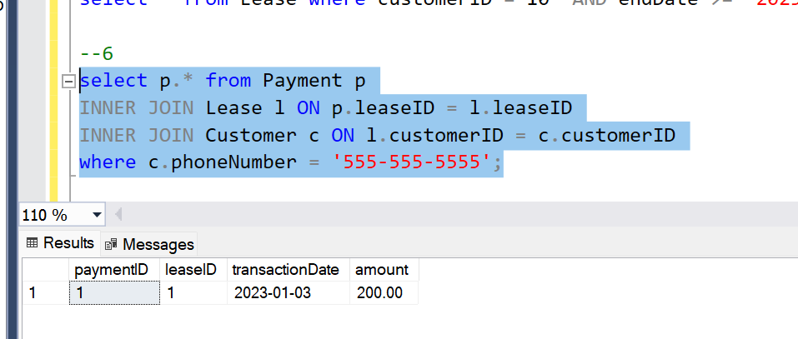

1. **Calculate the average daily rate of all available cars**

select AVG(dailyRate) as avgDailyRate from Vehicle where status = 'available';

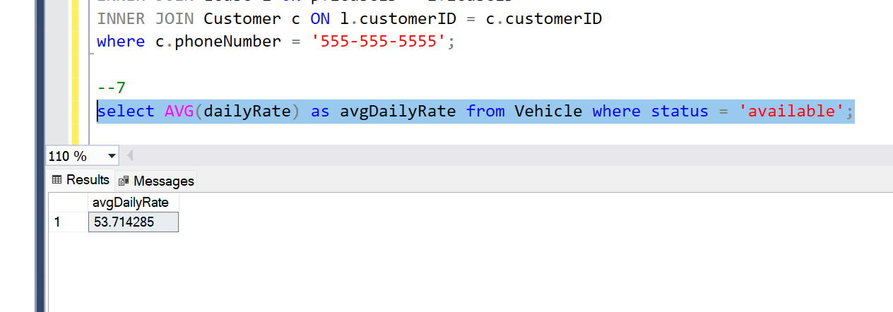

1. **Find the car with the highest daily rate.**

select * from Vehicle where dailyRate = (SELECT MAX(dailyRate) FROM Vehicle);

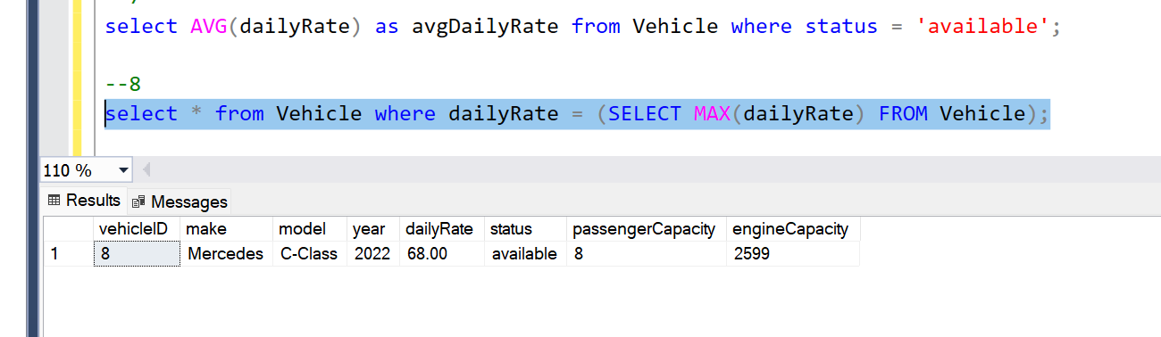

1. **Retrieve all cars leased by a specific customer**

insert into Customer (customerID, firstName, lastName, email, phoneNumber)

VALUES (3, 'Robert', 'Johnson', 'robert@example.com', '555-789-1234');

insert into Lease (leaseID, vehicleID, customerID, startDate, endDate, type) VALUES

(3, 3, 3, '2023-03-10', '2023-03-15', 'Daily'),

(6, 4, 3, '2023-06-15', '2023-06-30', 'Monthly'),

(9, 3, 3, '2023-09-07', '2023-09-10', 'Daily');

Select distinct v.* from Vehicle v

INNER JOIN Lease l ON v.vehicleID = l.vehicleID

where l.customerID = 3;

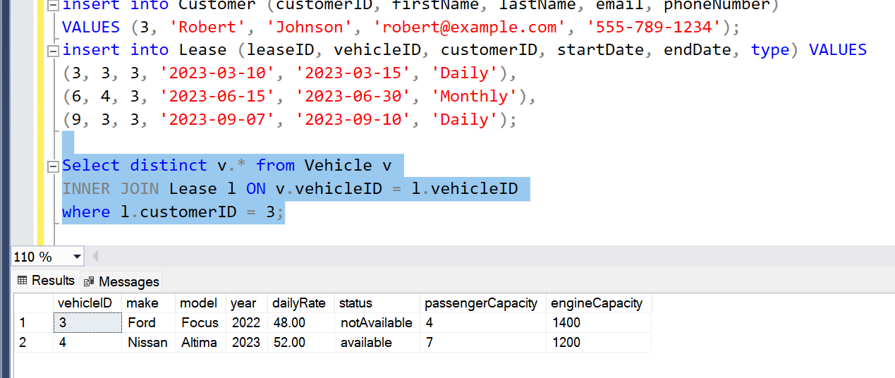

1. **Find the details of the most recent lease**

select * from Lease where startDate = (select MAX(startDate) from Lease);

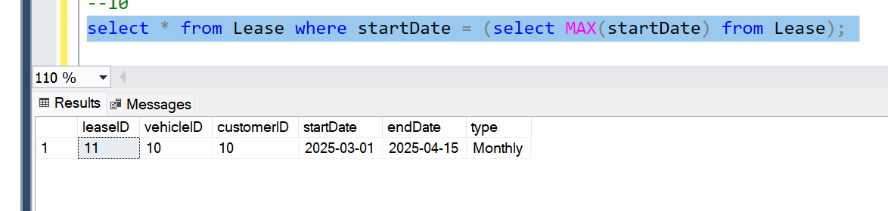

1. **List all payments made in the year 2023.**

select *from Payment where YEAR(transactionDate) = 2023;

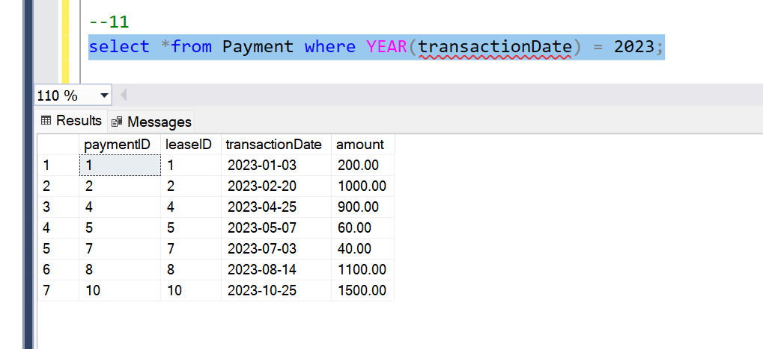

1. **Retrieve customers who have not made any payments.**

select c.* from Customer c

LEFT JOIN Lease l ON c.customerID = l.customerID

LEFT JOIN Payment p ON l.leaseID = p.leaseID

where p.paymentID is null;

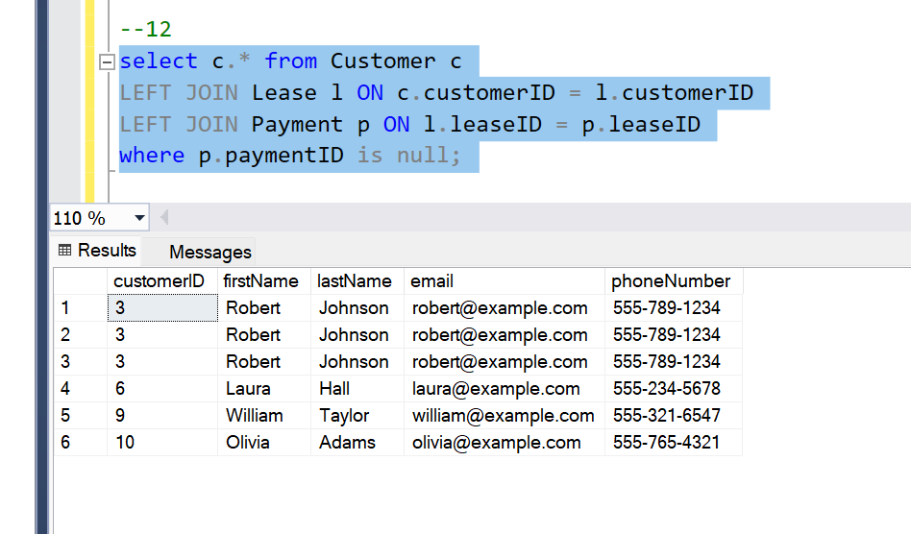

1. **Retrieve Car Details and Their Total Payments**.

select v.vehicleID, v.make, v.model, SUM(p.amount) AS totalPayments from Vehicle v

LEFT JOIN Lease l ON v.vehicleID = l.vehicleID

LEFT JOIN Payment p ON l.leaseID = p.leaseID

group by v.vehicleID, v.make, v.model;

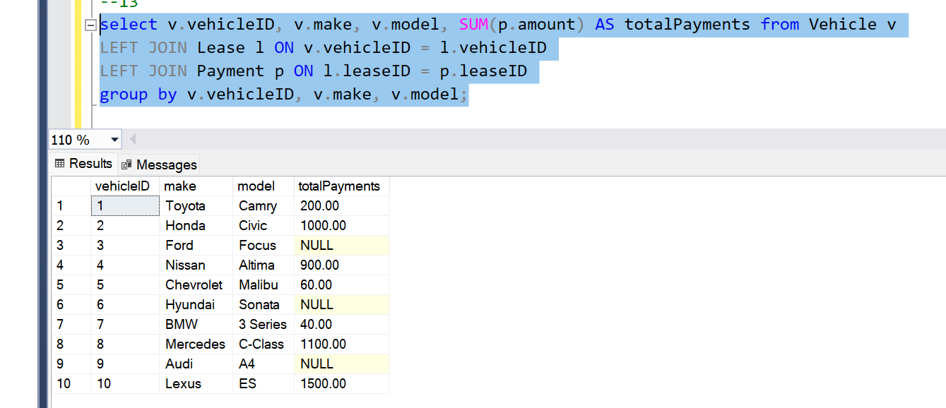

1. **Calculate Total Payments for Each Customer**

select c.customerID, c.firstName, c.lastName, SUM(p.amount) AS totalPayments from Customer c

LEFT JOIN Lease l ON c.customerID = l.customerID

LEFT JOIN Payment p ON l.leaseID = p.leaseID

Group by c.customerID, c.firstName, c.lastName;

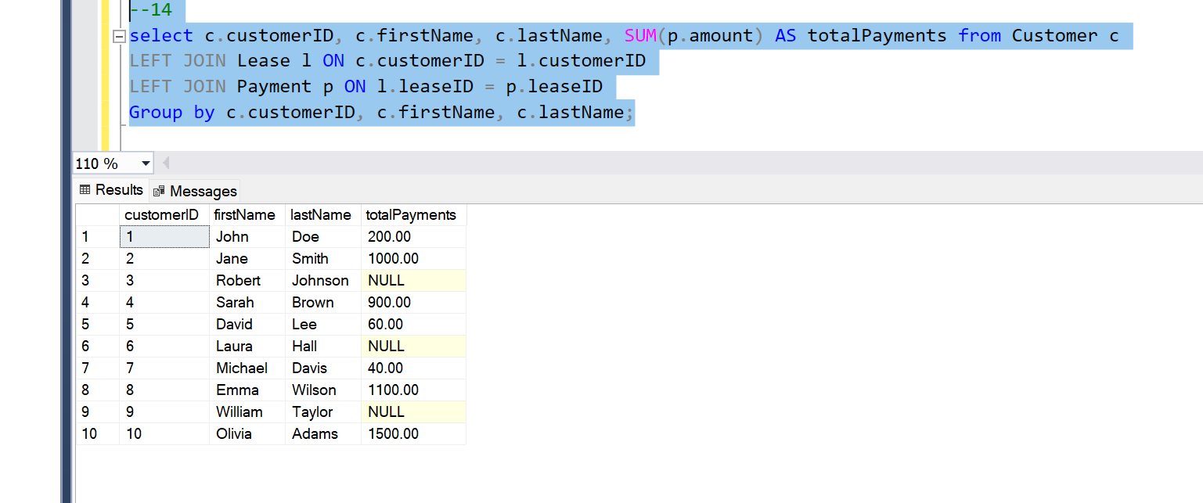

1. **List Car Details for Each Lease**

select l.leaseID, v.make, v.model, v.year, v.dailyRate from Lease l

INNER JOIN Vehicle v ON l.vehicleID = v.vehicleID;

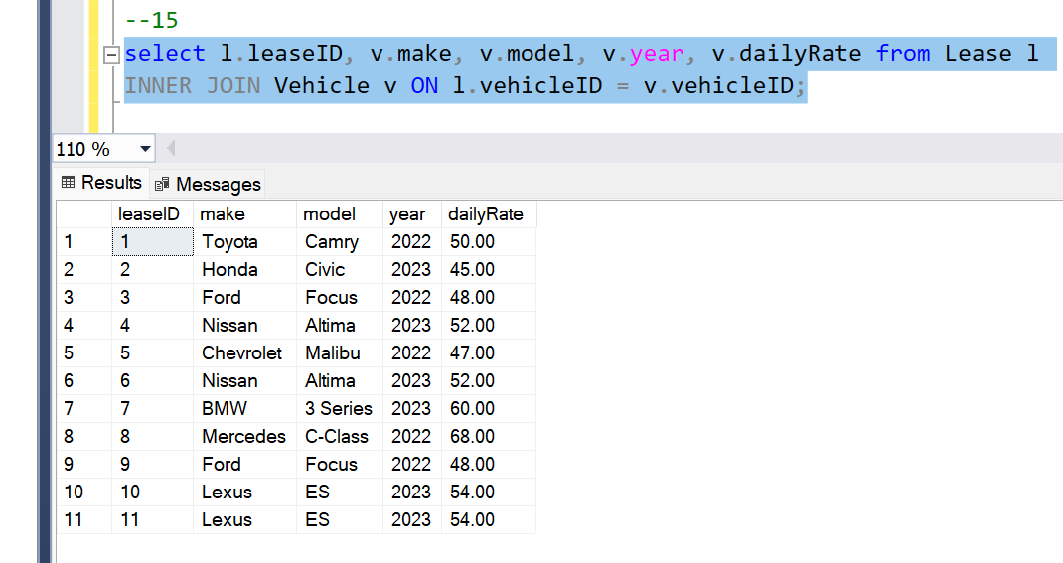

1. **Retrieve Details of Active Leases with Customer and Car Information**

select l.leaseID, c.firstName, c.lastName, v.make, v.model, l.startDate, l.endDate from Lease l

INNER JOIN Customer c ON l.customerID = c.customerID

INNER JOIN Vehicle v ON l.vehicleID = v.vehicleID

where l.endDate >= '2025-03-30';

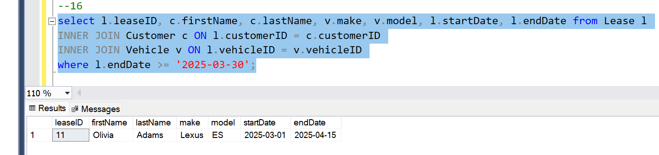

1. **Find the Customer Who Has Spent the Most on Leases**

select c.customerID, c.firstName, c.lastName, SUM(p.amount) AS totalSpent from Customer c

INNER JOIN Lease l ON c.customerID = l.customerID

INNER JOIN Payment p ON l.leaseID = p.leaseID

group by c.customerID, c.firstName, c.lastName

order by totalSpent DESC;

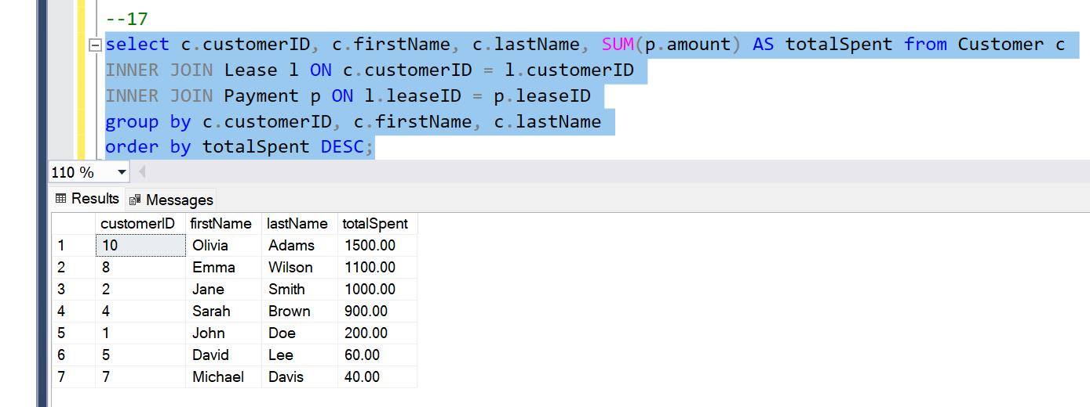

1. **List All Cars with Their Current Lease Information**

select v.vehicleID, v.make, v.model, l.leaseID, l.startDate, l.endDate from Vehicle v

LEFT JOIN Lease l ON v.vehicleID = l.vehicleID

AND l.endDate >= '2025-03-30';

